CMPT 762

Computer Vision

Assignment 5

Gokul Mohanarangan

gma56@sfu.ca

301436162

**NOTE : 2 free late days that are left are intended to be used here**

**3.1.1**

**F :**

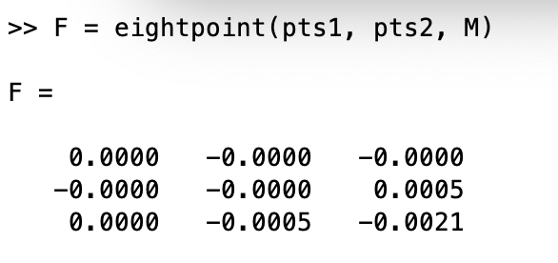

OR

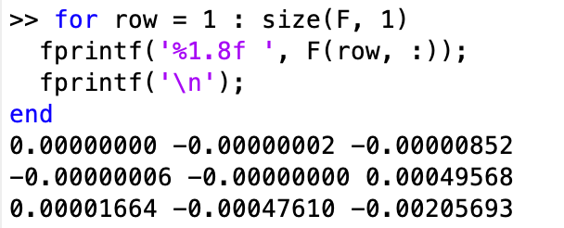

**Visualizing some epipolar lines:**



**3.1.2**



**SIMILARITY METRIC:**

**Root squared error between the points or the Euclidean distance**

sqrt(sum((candidate_points_1 - candidate_points_2) .^ 2, "all"));

**Failed matching algorithm:**

When I choose points near the corner of the temple structure the result is slightly incorrect and ends up being close but around the particular point chosen. This may be because the distance between the patch is influenced by the dark background of the pixels. Since the distance metric might be similar for several points around that area, the correspondence point chosen is slightly off.

**3.1.3**

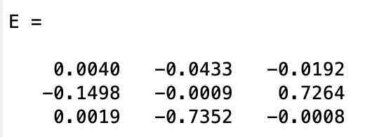

**3.1.4**

According to slides, solution is the eigenvector

corresponding to smallest eigenvalue of A(T) . A which is the right singular matrix. Here, by choosing the eigen vector of V with the smallest value (last), we can determine the triangulation points.

In the testing script, we pass the Essential matrix to camera2() which returns 4 extrinsic matrices. In order to choose the right one, we have some methods.

1. from slidedeck 20-stereo => By checking the determinant of the solution i.e) it has to be equal to 1
2. By checking the last element (w) of the pts3d. i.e) all values should be positive here. This is called the positive depth test.

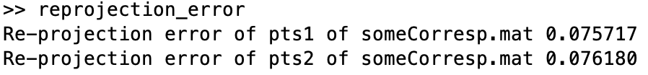

**3.1.5**

**Sample Reconstructions**







**3.2.1**



**3.2.2**



**3.2.3**



**3.3.1**

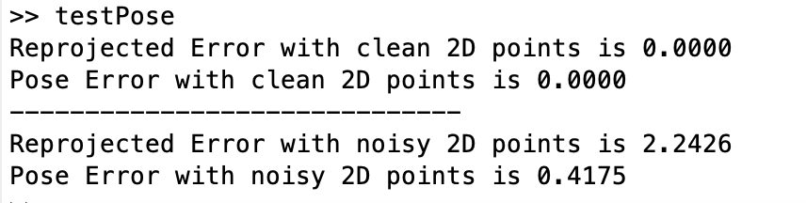

**3.3.2**

